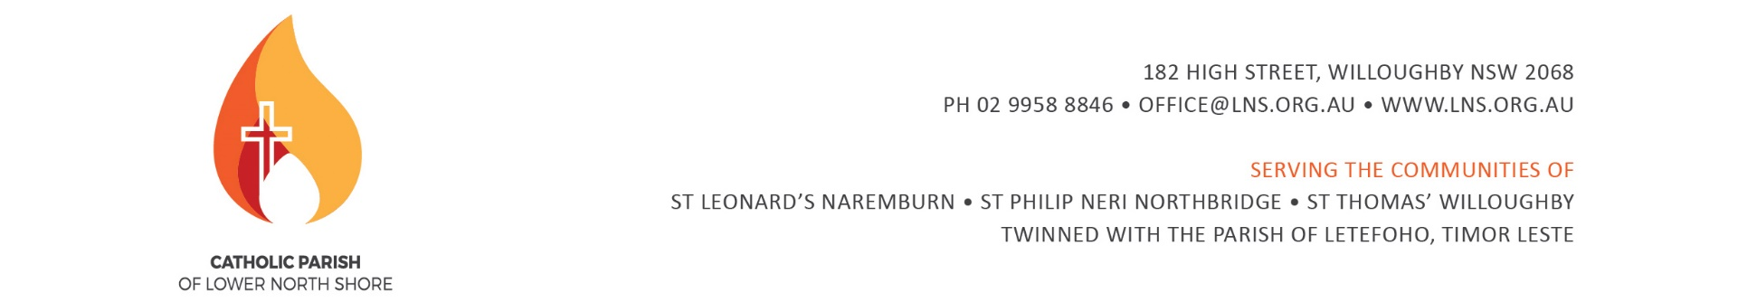

# **CONFIRMATION ENROLMENT FORM 2021**

**To enrol for the Sacrament of Confirmation:**

1. Complete this form and return it to the Parish Office or email [sacraments@LNS.org.au](mailto:sacraments@LNS.org.au)
2. Make a $100 payment to the Parish via our website <https://www.bpoint.com.au/payments/lnshoreparish>

Please click on ‘Sacramental Program’ in the drop down menu. This one-off administration fee serves as an enrolment fee for the sacramental program (Confirmation, First Reconciliation and First Holy Communion).

1. Please email your receipt number to [sacraments@LNS.org.au](mailto:sacraments@LNS.org.au) once payment has been made. Payments can also be made at the Parish Office.
2. Provide a copy of the candidate’s Baptismal Certificate, and a picture (face shot) in jpeg format.

|  |  |  |  |
| --- | --- | --- | --- |
| **DETAILS OF CANDIDATE** | | | |
| Christian Name(s): |  | Surname: |  |
| Gender: |  | Date of Birth: |  |
| School: |  | Class Year: |  |

|  |  |
| --- | --- |
| **CONFIRMATION NAME** *Please pick a name from the list of canonised Saints, and please use the full saint’s name.eg. (Mary, Mother of God, or John the Baptist). Encourage your child to research and learn about the life of their chosen saint.* | |
| Saint Name: |  |

|  |  |  |  |  |  |
| --- | --- | --- | --- | --- | --- |
| **DETAILS OF CANDIDATE’S BAPTISM** *(Please provide a copy of the Baptismal certificate)* | | | | | |
| Parish Name: |  | | | Baptism Date: |  |
| Parish Address: |  | | | | |
| State / Country: |  | | Postcode: |  | |
| **DETAILS OF FATHER** | | | | | |
| Christian Name(s): |  | Surname: | |  | |
| Religion: |  | | | | |
| **DETAILS OF MOTHER** | | | | | |
| Christian Name(s): |  | Maiden name: | |  | |
| Religion: |  | Surname: | |  | |

|  |  |  |  |  |
| --- | --- | --- | --- | --- |
| **CONTACT DETAILS** | | | | |
| Home Address: | |  | | |
| Best Email Contact: | |  | | |
| Home Phone: | |  | Mobile Phone: |  |
| **SPONSOR’S DETAILS** | | | | |
| Full Name: |  | | | |
| Name of Local Parish: |  | | | |
| Religion: | ⃣ Over the age of 16 | | | |

**IMPORTANT INFORMATION**

* A candidate must have at least one Catholic parent or guardian in order for the child to receive the sacrament of Confirmation.
* Sponsors are ‘…to take care that the confirmed person behaves as a true witness of Christ and faithfully fulfils the obligations inherent in this sacrament’ (Canon Law no. 892).
* According to Canon Law (no. 874) a person is permitted to be a Sponsor of a Confirmation candidate if they meet the following criteria:
  + be designated by the one to be baptised, by the parents or the person who takes their place, or in their absence by the pastor or minister and have the aptitude and intention of fulfilling this function;
  + have completed the sixteenth year of age, unless the diocesan bishop has established another age, or the pastor or minister has granted an exception for a just cause;
  + be a Catholic who has been confirmed and has already received the most holy sacrament of the Eucharist and who leads a life of faith in keeping with the function to be taken on;
  + not be bound by any canonical penalty legitimately imposed or declared;
  + not be the father or mother of the candidate;
  + not belong to a non-Catholic ecclesial community.
* If you are not yet a registered parishioner, please also complete a **Parishioner Information Form.**

This form can be downloaded from our website or copies are available in the foyer of our Churches.

Thank you for supporting your child’s faith development journey.

***Please send your forms (Confirmation Enrolment Request & Copy of Baptism Certificate)***

***or direct any enquiries to:***

**Jessica Bousimon - Sacramental Co-ordinator**

E: [sacraments@LNS.org.au](mailto:sacraments@LNS.org.au) P: 9958 8846