ST BENEDICT’S PARISH ROSTER
February -May 2025

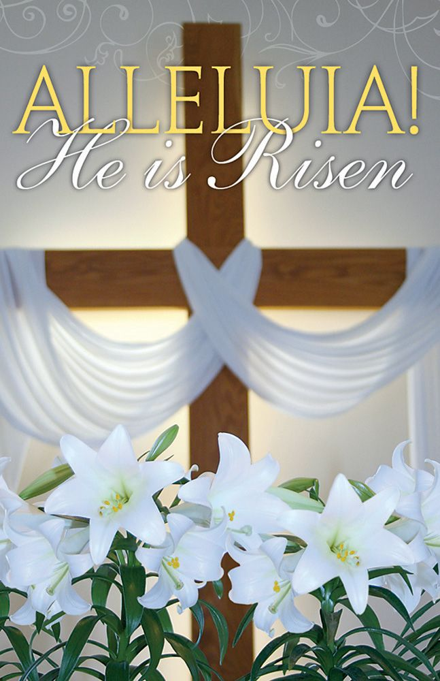
22/2/25 to 23/2/25 – 7th Sunday in Ord. Time Year C |  |  |  |  |  |  | 15/3/25 to 16/3/25 –2nd Sunday of Lent Year C
 | 7.00 p.m. |  | 9.00 a.m. |  | 10.30 a.m. |  |  | 7.00 p.m. | 9.00 a.m. | 10.30 a.m.
SS |  |  | Paul E |  | George A |  | SS |  | Paul C | Paul E
R1 | Natasha S |  | Judy H |  | Leanne A |  | R1 | Miriam B | Mary C | CHILDREN’S MASS
R2 | Maria G |  | Keith W |  | Lorna B |  | R2 | Margaret B | Lorraine D
P | St Carol T |  | Nigel M |  | Sharon O |  | P | Sr Carol T | Kath M
TV |  |  | Roderick R |  | Trey O |  | TV |  | Jules O | Jutrisa family
EM |  |  |  |  |  |  | EM
EM |  |  |  |  |  |  | EM
EM |  |  |  |  |  |  | EM
EM |  |  |  |  |  |  | EM
M |  |  | Rebecca R |  | Karina S |  | M |  | Melanie H | Melanie H
M |  |  | Marisa Q |  | John T |  | M |  | Marisa Q | Theresa N
M |  |  | Theresa N |  | Noelle T |  | M |  | Pauline H | Martina J
M |  |  |  |  |  |  | M |  | Keith W | Sandra M
MT |  |  | Mary A |  |  |  | MT |  | Teresa G | Mary A
FL | Angela S |  |  |  |  |  | FL | No flowers during Lent
1/3/25 to 2/3/25 – 8th Sunday in Ord. Time Year C |  |  |  |  |  |  | 22/3/25 to 23/3/25–3rd Sunday of Lent Yr C
 | 7.00 p.m. |  | 9.00 a.m. |  | 10.30a.m. |  |  | 7.00 p.m. | 9.00 a.m. | 10.30 a.m.
SS |  |  | Nigel M |  | Paul E |  | SS |  | Nigel M | George A
R1 | Mary C | Teresa G |  | CHILDREN’S MASS |  |  | R1 | Sr Carol T | Gabrielle W | Jutrisa family
R2 | Miriam B | Ann L |  |  |  |  | R2 | Natasha S | Judy H | Sandra/Doug M
P | Maria G | Lorraine D |  |  |  |  | P | Margaret B | Matt W | Sharon O
TV |  | Jules O |  | Jutrisa family |  |  | TV |  | Jules O | Trey O
EM |  |  |  |  |  |  | EM
EM |  |  |  |  |  |  | EM
EM |  |  |  |  |  |  | EM
EM |  |  |  |  |  |  | EM
M |  |  | Melanie H |  | Melanie H |  | M |  | Karina S | Melanie H
M |  |  | Keith W |  | Jack F |  | M |  | John T | Theresa N
M |  |  | Theresa N |  | Martina J |  | M |  | Noelle T | Jack F
M |  |  | Pauline H |  | Sandra M |  | M
MT |  |  | Sophie R |  | Robin B |  | MT |  | Mandah V
FL | Gabrielle W |  |  |  |  |  | FL | No flowers during Lent
8/3/25 to 9/3/25– 1st Sunday of Lent Year C |  |  |  |  |  |  | 29/3/25 to 30/3/25–4th Sunday of Lent Yr C
 | 7.00 p.m. |  | 9.00 a.m. |  | 10.30a.m |  |  | 7.00 p.m. | 9.00 a.m. | 10.30 a.m.
SS |  |  | Lorraine D |  | George A |  | SS |  | Lorraine D
R1 | Natasha S |  | Kath M |  | Lorna B |  | R1 | Margaret B | Ann L | John family
R2 | Sr Carol T |  | Judy H |  | Leanne A |  | R2 | Maria G | Nigel M | John family
P | Miriam B |  | Gabrielle W |  | John family |  | P | Mary C | Paula E | Lorna B
TV |  |  | Nigel M |  | Theresa G |  | TV |  | Roderick R | Jutrisa family
EM |  |  |  |  |  |  | EM
EM |  |  |  |  |  |  | EM
EM |  |  |  |  |  |  | EM
EM |  |  |  |  |  |  | EM
M |  |  | Karina S |  | Melanie H |  | M |  | Rebecca R | Melanie H
M |  |  | John T |  | Jack F |  | M |  | Keith W | Noelle T
M |  |  | Noelle T |  | Martina J |  | M |  | Marisa Q | John T
M |  |  |  |  |  |  | M |  | Teresa G
MT |  |  | Tania T |  |  |  | MT |  | Tania T
FL | No flowers during Lent |  |  |  |  |  | FL | No flowers during Lent
5/4/25 to 6/4/25 – 5th Sunday of Lent Year C |  |  |  |  |  |  | 26/4/25 to 27/4/25 – 2nd Sunday of Easter Yr C
 | 7.00 p.m. |  | 9.00 a.m. |  | 10.30 a.m. |  |  | 7.00 p.m. | 9.00 a.m. | 10.30 a.m.
SS |  |  | Paul C |  | Paul E |  | SS |  | Lorraine D | George A
R1 | Mary C |  | Lorraine D |  | CHILDREN’S MASS |  | R1 | Sr Carol T | Nigel M | Matt W
R2 | Miriam B |  | Mary C |  | CHILDREN’S MASS |  | R2 | Mary C | Fogarty family | Lorna B
P | Maria G |  | Kath M |  | CHILDREN’S MASS |  | P | Natasha S | Fogarty family | Gabrielle W
TV |  |  | Nigel M |  | Trey O’C |  | TV |  | Roderick R | Teresa G
EM |  |  |  |  |  |  | EM
EM |  |  |  |  |  |  | EM
EM |  |  |  |  |  |  | EM
EM |  |  |  |  |  |  | EM
M |  |  | Melanie H |  | Karina S |  | M |  | Rebecca R | Melanie H
M |  |  | Theresa N |  | John T |  | M |  | Theresa N | Keith W
M |  |  | Jack/Adam F |  | Noelle T |  | M |  | Jack/Adam F | Sandra M
M |  |  |  |  |  |  | M |  | Pauline H
MT |  |  | Sophie R |  | Robin B |  | MT |  | Teresa G
FL | No flowers during Lent |  |  |  |  |  | FL | Therese & Matt M
 |  |  |  |  |  |  |  | SCHOOL HOLIDAYS END 29th April
12/4/25 to 13/4/25 – Palm Sunday Year C |  |  |  |  |  |  | 3/5/25 to 4/5/25- 3rd Sunday of Easter Yr C
 | 7.00 p.m. |  | 9.00 a.m. |  | 10.30 a.m. |  |  | 7.00 p.m. | 9.00 a.m. | 10.30 a.m.
SS |  |  | Lorraine D |  | George A |  | SS |  | Paul C | Paul E
R1 | Maria G |  | Ann L |  | Sandra/Doug M |  | R1 | Natasha S | Matt W | CHILDREN’S MASS
R2 | Natasha S |  | Matt W |  | Fogarty family |  | R2 | Maria G | Ann L
P | Miriam B |  | Judy H |  | Leanne A |  | P | Mary C | Mary C
TV |  |  | Teresa G |  | Jutrisa family |  | TV |  | Mary A | Trey O’C
EM |  |  |  |  |  |  | EM
EM |  |  |  |  |  |  | EM
EM |  |  |  |  |  |  | EM
EM |  |  |  |  |  |  | EM
M |  |  | Melanie H |  | Melanie H |  | M |  | Melanie H | Karina S
M |  |  | John T |  | Jack/Adam F |  | M |  | Marisa Q | John T
M |  |  | Noelle T |  | Martina J |  | M |  | Keith W | Noelle T
M |  |  |  |  | Sandra M |  | M |  | Teresa G
MT |  |  | Mary A |  |  |  | MT |  | Mandah V | Robin B
FL | No flowers during Lent |  |  |  |  |  | FL | Hannah A
SCHOOL HOLIDAYS BEGIN 15th April
19/4/25 to 20/4/25 – Easter Vigil & Easter Sunday Yr C |  |  |  |  |  |  | 10/5/25 to 11/5/25 –4th Sunday of Easter Yr C
 | 7.00p.m. |  | 9.00 a.m. |  | 10.30 a.m. |  |  | 7.00 p.m. | 9.00 a.m. | 10.30 a.m.
SS | SEE SEPARATE ROSTERS WHICH WILL BE POSTED OUTSIDE THE SACRISTY |  |  |  |  |  | SS |  | Nigel M | George A
R1 |  |  |  |  |  |  | R1 | Mary C | Ann L | Teresa G
R2 |  |  |  |  |  |  | R2 | Miriam B | Lorraine D | John family
P |  |  |  |  |  |  | P | Margaret B | Ann L | John family
TV |  |  |  |  |  |  | TV |  | Jules O | Fogarty family
EM |  |  |  |  |  |  | EM
EM |  |  |  |  |  |  | EM
EM |  |  |  |  |  |  | EM
EM |  |  |  |  |  |  | EM
M |  |  |  |  |  |  | M |  | Melanie H | Melanie H
M |  |  |  |  |  |  | M |  | Keith W | Jack/Adam F
M |  |  |  |  |  |  | M |  | Marisa Q | Martina J
M |  |  |  |  |  |  | M
MT |  |  |  |  |  |  | MT |  | Tania T
FL |  |  |  |  |  |  | FL | Mona M

