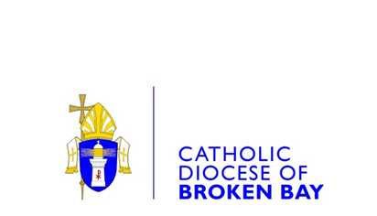
CATHOLIC DIOCESE OF BROKEN BAY

CONFRATERNITY OF CHRISTIAN DOCTRINE (CCD)
APPROVED PROVIDER OF SPECIAL RELIGIOUS EDUCATION (SRE) COMPLAINT FORM

1. Complainant Details
Please select from the following. I am a/an:
Parent Student NSW DoE School/Employee

CCD Employee SRE Teacher Other
2. Personal Details
 |  | Mr |  |  | Mrs |  | Ms |  |  | Other:
Surname
First Name
3. Contact Details
Address
 |  |  |  |  |  |  |  |  |  | Postcode
Email Address
Daytime Phone No./Mobile
Preferred Contact Method: |  |  |  | Phone |  | Letter |  |  | Email
4. Subject of Complaint
(Child Protection complaints will be referred to the school Principal and the Diocesan Safeguarding Office (Chancery & Parishes)
Child Protection Classroom Management SRE Teacher
Curriculum School Other_____________
5. Complaint Summary
When it happened

Where it happened

Who was involved

What happened (Details of your complaint)

What would you like to happen to resolve your complaint?
6. Acknowledgement
All information provided above is true and correct to the best of my knowledge.
Name |  |  |  |  |  |  |  | Date:
Signature
7. Privacy Notice
The information provided in this Form is collected and handled in accordance with the Catholic Diocese of Broken Bay’s Privacy Policy (available on the Diocesan website at www.bbcatholic.org.au/privacy-policy) and we will only use the information collected on this form to resolve your complaint. Your personal information will not be disclosed without your consent, except where required or authorised by law.
I have read and acknowledged the privacy policy/notice (required field)

8. Office Use Only
Action Officer
Position |  | Date:
Complaint Lodged
Online Phone In Person Email In Writing

Note for online form:
Upon submission this form will be forwarded to the CCD Diocesan Coordinator.

FORM REVIEW
Review of this Form, related guidelines and resources will be undertaken every three years by the CCD Diocesan Coordinator in consultation with the Director, Mission Broken Bay, the Human Resources Manager (Chancery), the Safeguarding Manager (Chancery & Parishes) and approved by the Diocesan Financial Administrator.
REVISION/ MODIFICATION HISTORY
Date | Version | Current Title | Summary of Changes | Approval Date | Commence-ment Date
30/10/18 | 1. | Confraternity of Christian Doctrine (CCD) Approved Provider of Special Religious Education (SRE) Complaint Form | New | Oct 2018 | Oct 2018
11/08/23 | 2. | Confraternity of Christian Doctrine (CCD) Approved Provider of Special Religious Education (SRE) Complaint Form | Reviewed and updated | Nov 2023 | Nov 2023

APPROVAL DATE/REVISION SCHEDULE
Approved by: Emma McDonald, Diocesan Financial Administrator
Date: 8 November 2023
To be revised: 8 November 2026

